***vi Commands:***

* i - switches from command mode to insert mode

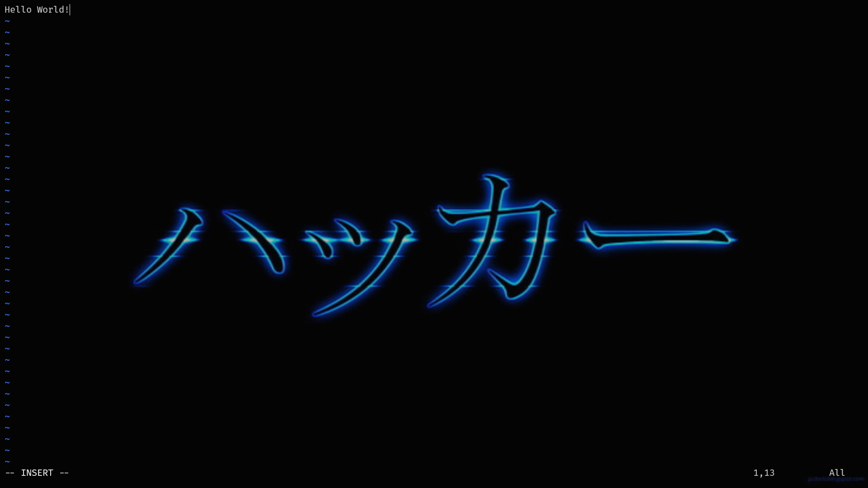

* O - inserts on the next line

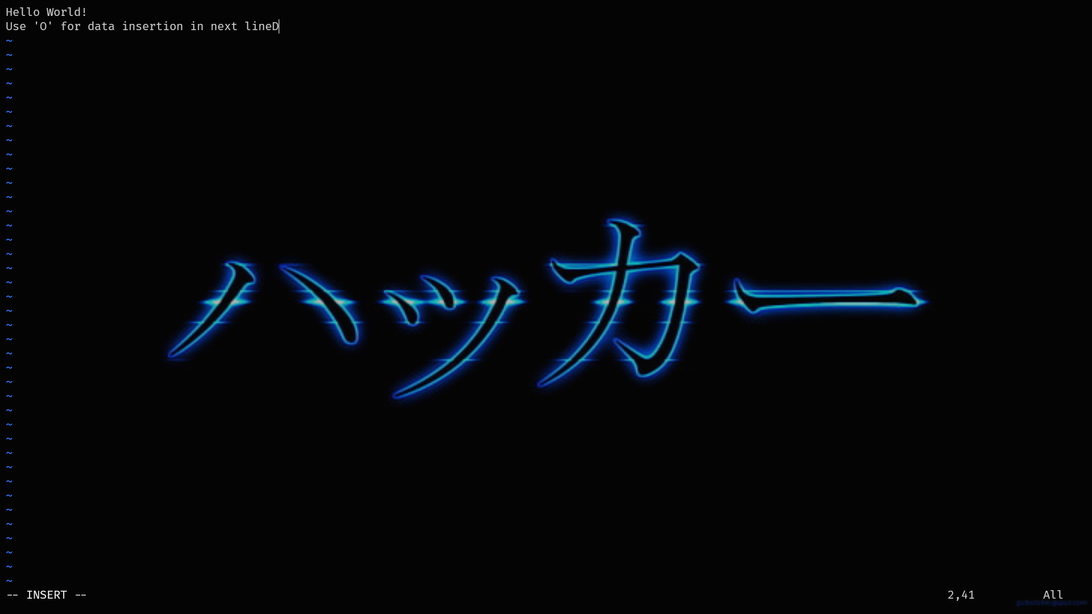

* a - Inserts after leaving a space
* esc - Moves to command mode

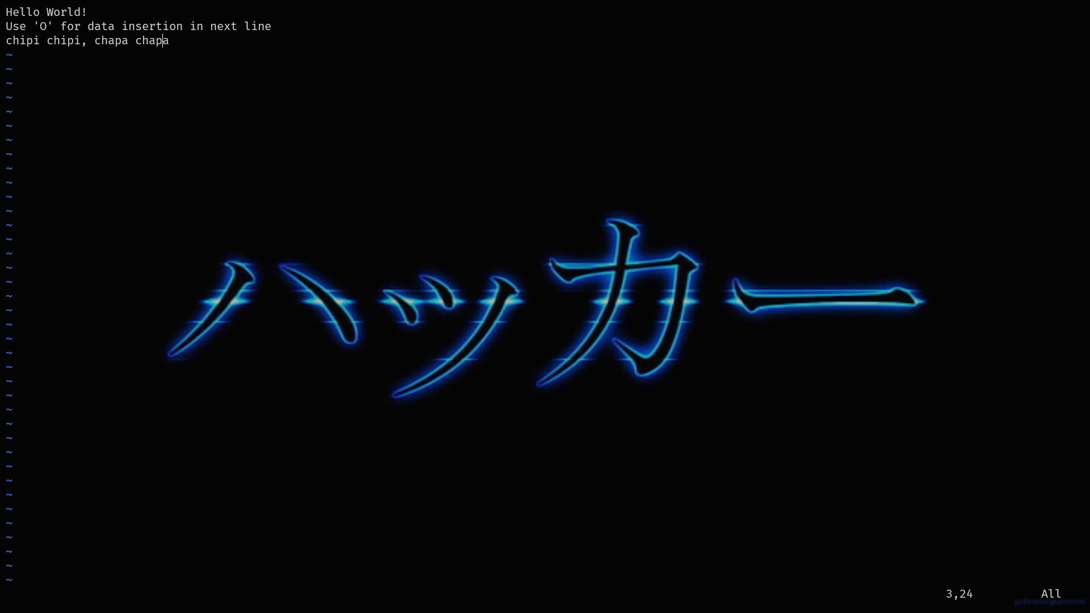

* :q! - quits the file without saving the changes
* :w - Saves and continue editing

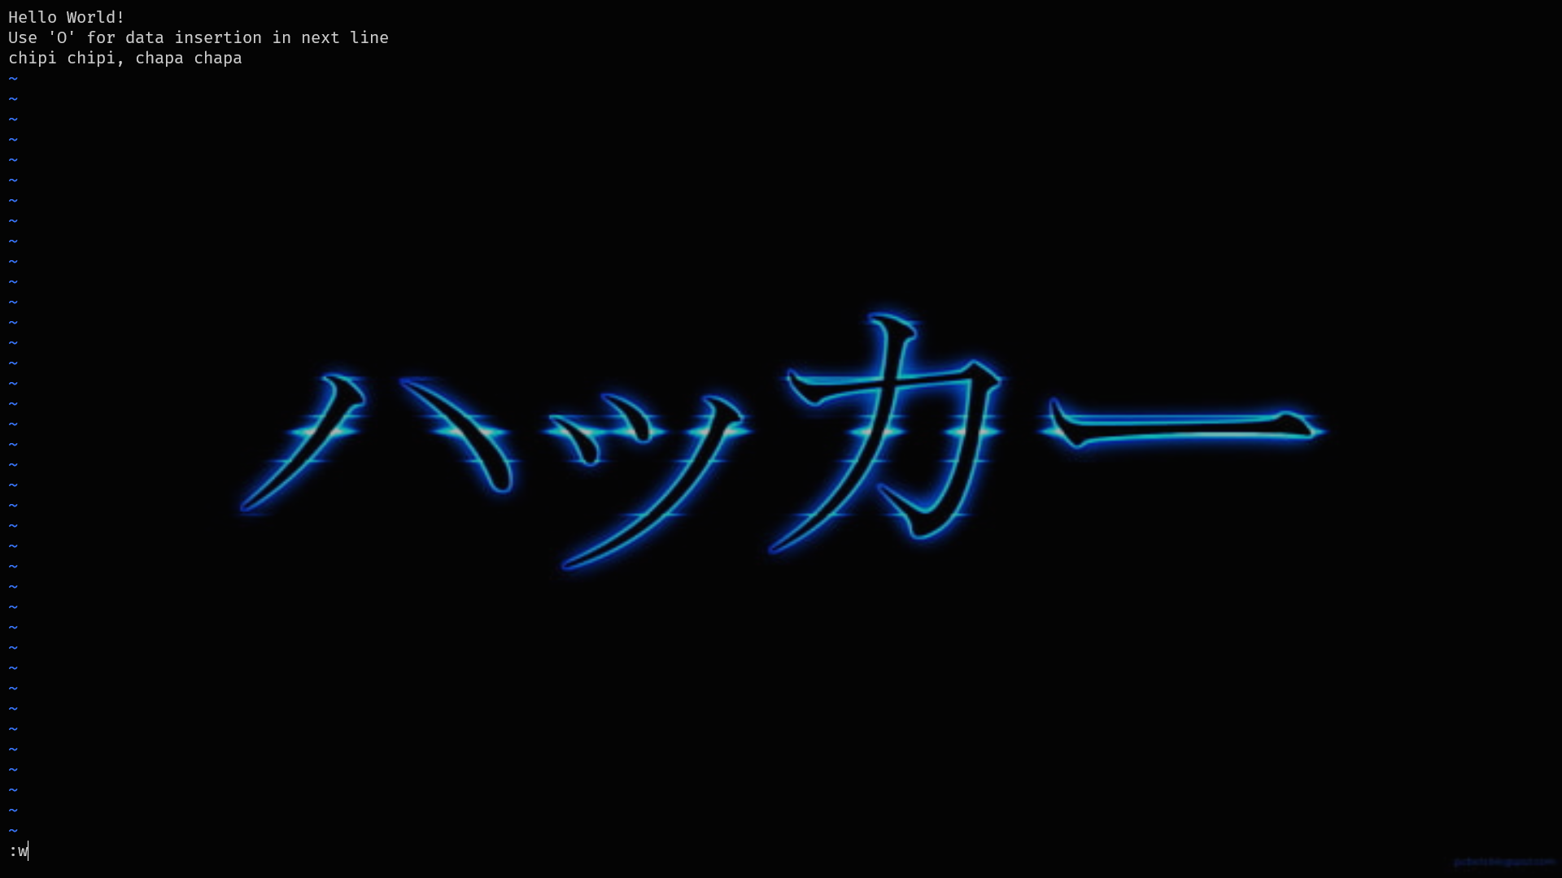

* :wq - saves the file and then quits
* Reopened after saving:

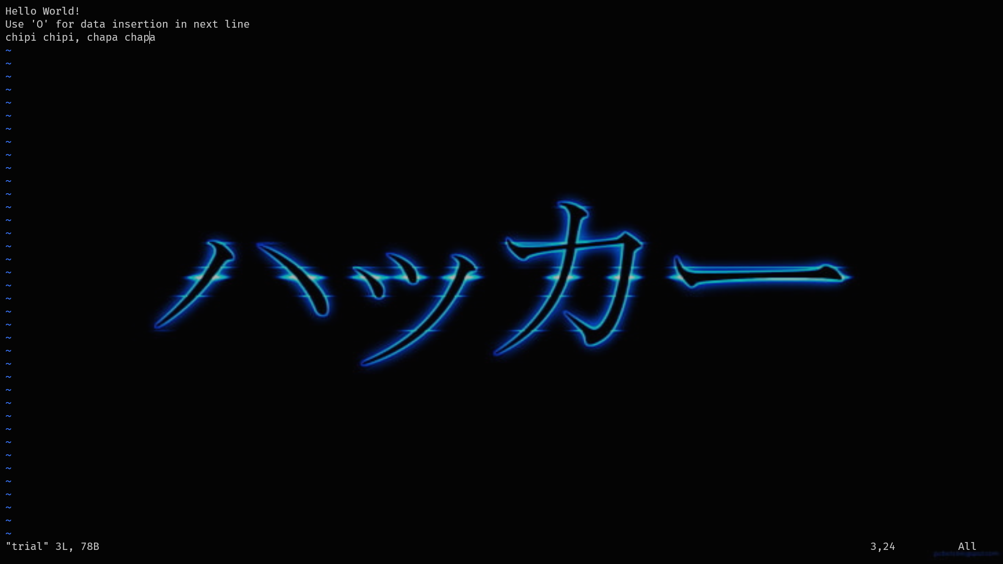

* r - Replace the character from the current cursor location
* d - delete

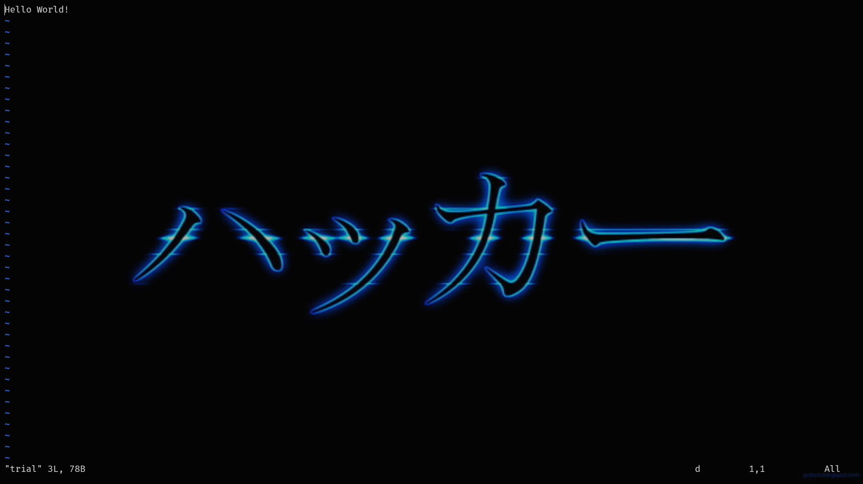

* u - undo

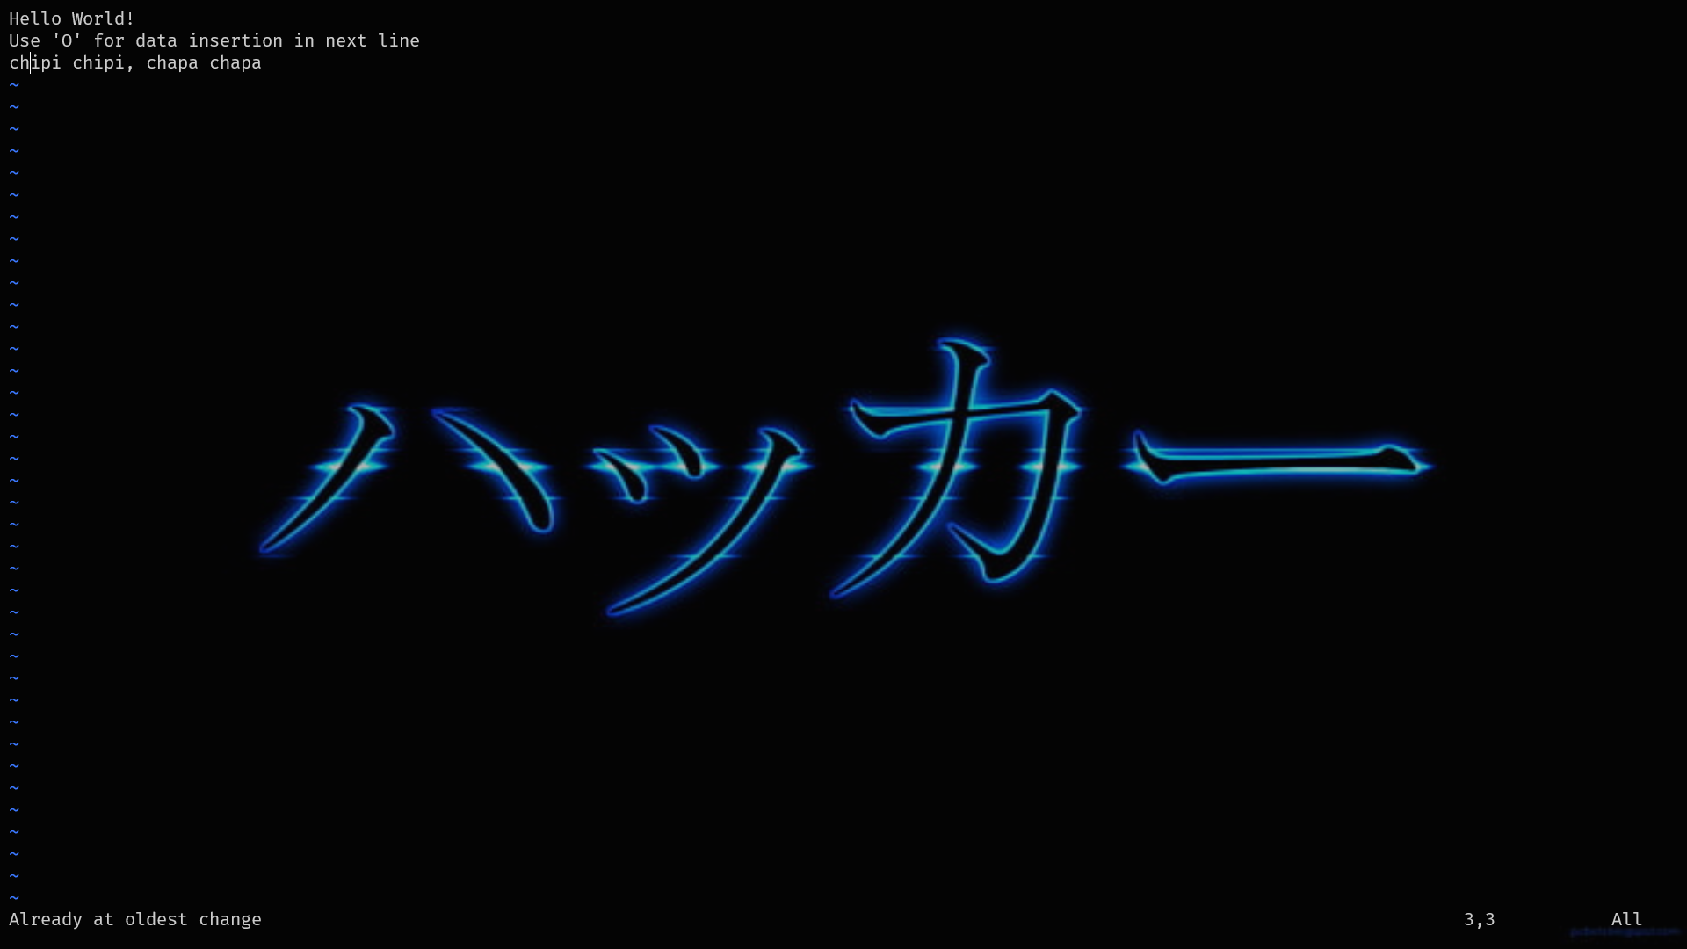

* x - removes one character
* /<STRING> - forward search

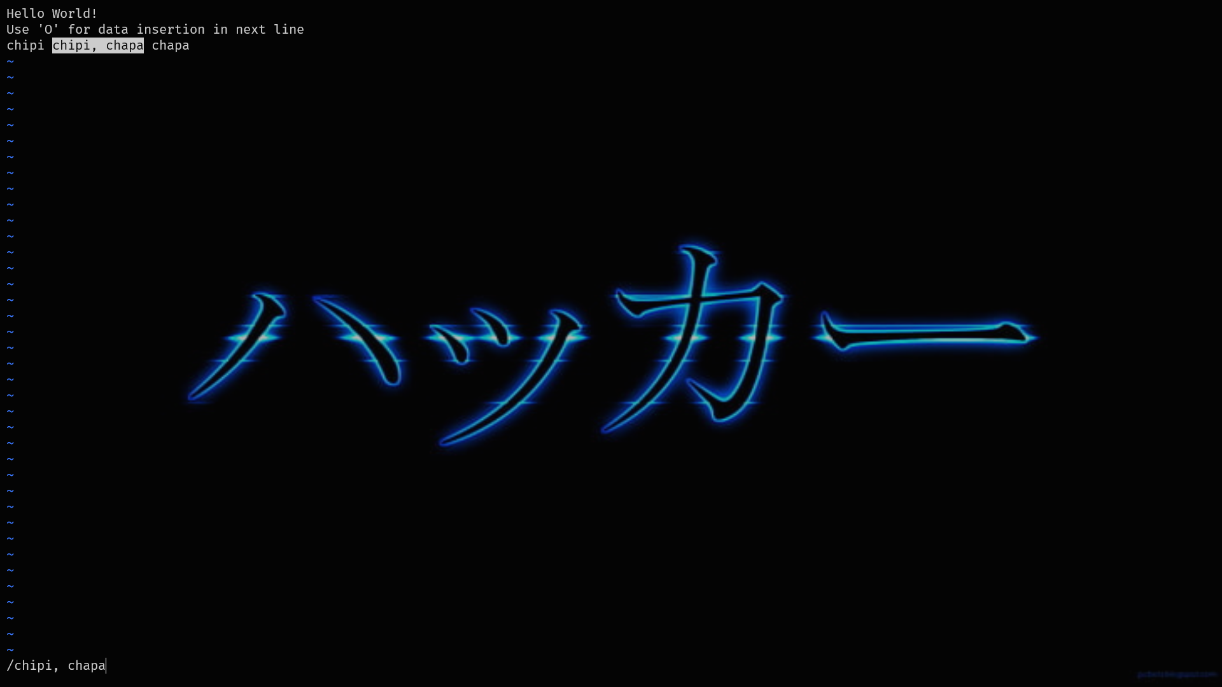

* ?<STRING> - backward search



* b — Go to the beginning of the word.
* e — Go to the end of the word.
* dd — Delete an entire line.
* Xdd — Delete X number of lines.
* :num — Display the current line’s line number.

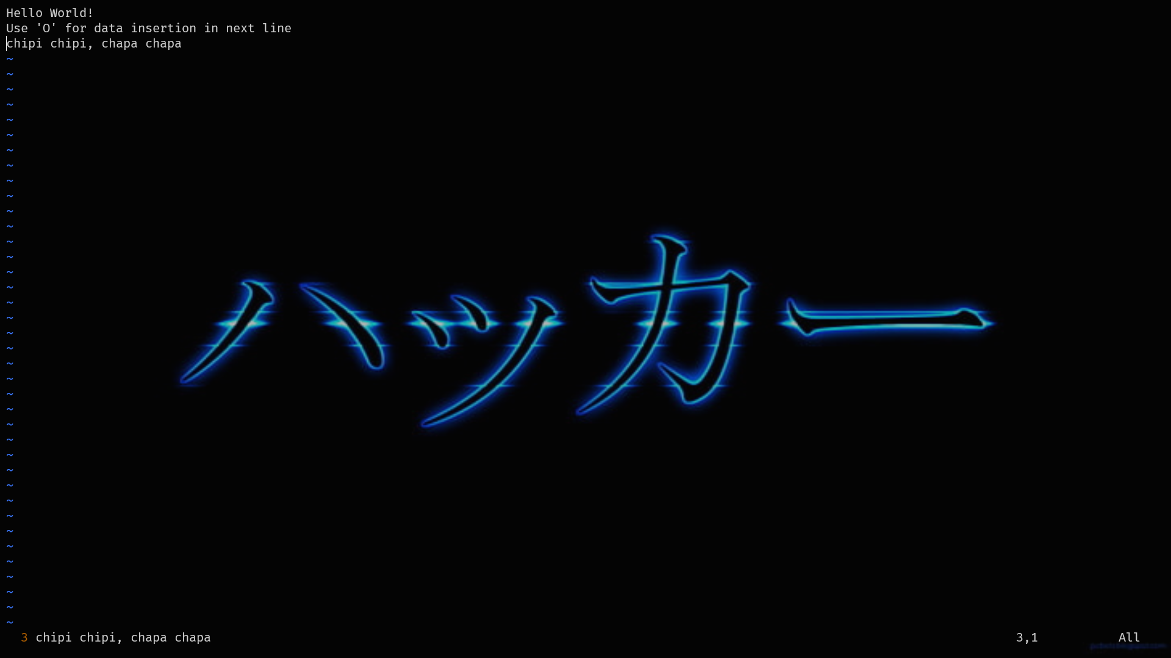

* h — Move left one character.
* j — Move down one line.
* k — Move up one line.
* l — Move right one character.
* :saveas – Renames the file

***emacs Commands:***

1. **General Shortcuts:**
   * **ctrl-x ctrl-f :** Find file or Open a file. This command prompts for a file name and opens it in buffer for editing. Also, it creates a new file if it doesn’t already exist.

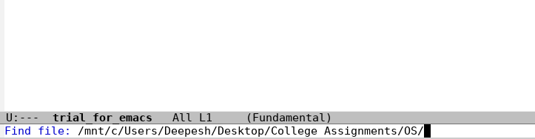

* + **ctrl-x ctrl-s :** Save File. This saves the current buffer content to the file.
  + **ctrl-x ctrl-w :** Write to file. This command prompts for a file name to save buffer.
  + 

1. **Search & Replace:**
   * **ctrl-s :** Search forward- prompts for a search terms and search it in the buffer from current cursor position to the end of the buffer.
   * **ctrl-r :** Search backwards/reverse- prompts for a search term and search from current position to the beginning of the buffer.
   * **ESC % :** Replace- prompts for a search term and a replacement term and replaces the first occurrence of the word in buffer after cursor.
2. **Moving Cursor:**
   * **ctrl-a :** Beginning of the line.
   * **ctrl-e :** End of line.
   * **ctrl-f :** Move forward by one character.
   * **ctrl-b :** Move back by one character.
   * **ctrl-n :** Move cursor to next line.
   * **ctrl-p :** Cursor to previous line.
   * **ESC > :** End of the buffer.
   * **ESC < :** Starting of the buffer.
   * **ESC f :** Move forward by one word.
   * **ESC b :** Move back by one word.
3. **Other Commands:**
   * **ctrl-z :** Stop Emacs and quit immediately without confirmation(All changes in buffer are lost)

**<NO SCREENSHOT, BECAUSE THE EMACS QUIT>**

* + **ctrl-g :** Cancel current command and revert back from command mode.
  + **ctrl-x u :** undo the last command.
  + **ctrl-x ctrl-c :** Save and quit.
  + **ctrl-h i :** Help in Emacs- describes emacs shortcuts and commands.
  + 
   